**Economic inactivity in UK cities – Findings**

**Summary**

* Economic inactivity is higher in cities outside the Greater South East.
* Demographically:
* Gender: female more likely to be economically inactive (27% F v 17% M)
* Ethnicity: ethnic minorities more likely to be economically inactive (30% v 21%)
* Age: young and old people more likely to be economically inactive than 25-49yo (38% 16-24yo, v 27% 50-64yo, v 13% 25-49yo)
* Skills: people with few or no qualifications way more likely to be economically inactive (36% v 13% for high-skilled people)
* Living arrangement: people not living in a couple more likely to be economically inactive (41%) than those living in a couple (32%)
* 27 per cent of economic inactive are students, 25 per cent look after family/home and 22 per cent are long term sick.
* The vast majority of the economic inactive (77%) do not want a job, but there seems to be no one good indicator to explain the variation on this indicator across the country.
* Overall economic inactivity is strongly correlated with the share of population with no qualifications in cities (correlation coefficient of 0.62), it has a negative correlation with GVA per worker (-0.40) and a positive correlation with unemployment rates (0.40).
* Economic inactivity and welfare spend per capita have a positive correlation (correlation coefficient (0.47)

1. **What does economic inactivity look like in cities up and down the country?**

**Overview**

* As with many other things, there is a quite clear North/South divide, with cities in the Greater South East having a lower share of economic inactive and cities in the North and Midlands seeing higher levels of inactivity.
* In Great Britain, 22 per cent of the working age population was economically inactive in 2017.
* Top 5 cities for economic inactivity are: Dundee (32%), Blackburn (31%), Liverpool (29%), Birmingham (28%) and Swansea (28%). All the top 10 cities for economic inactivity are outside the Greater South East.
* 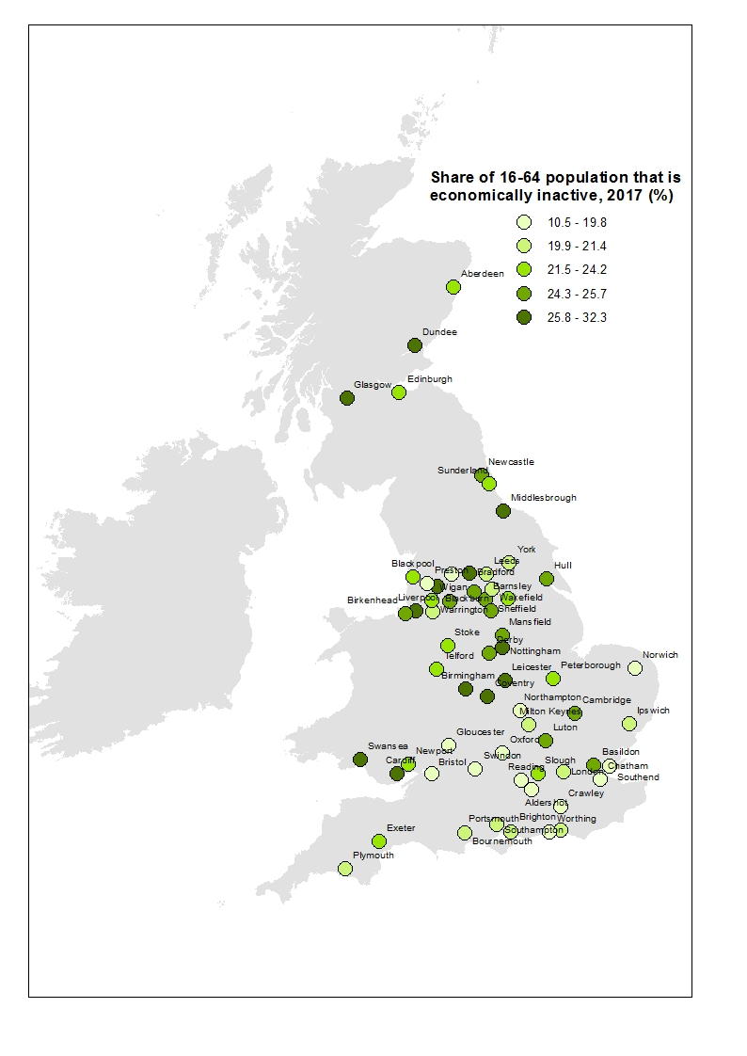Bottom 10 cities for economic inactivity are: Crawley (11%), Worthing (15%), Swindon (16%), Oxford (17%) and Gloucester (17%). All the bottom 10 cities – excluding Preston – are in the Greater South East.

**Breakdown by gender**

* In Great Britain, women (27%) are more likely to be economically inactive then men (17%).
* This is also true for every city apart from two: Dundee and Exeter.
* In Dundee, both female and male economic inactivity are high, with make economic inactivity 3.5 percentage points higher.
* In Exeter, the difference is much bigger and while the city has the second highest inactivity rate for men, it has one of the lowest for women (59/62 cities).

**Breakdown by ethnicity**

* In Great Britain, people from ethnic minorities (30%) are more likely to be economically inactive than people from a white ethnic group (21%).
* This is also true in most UK cities, with the exception of a few places – Barnsley, Birkenhead, Chatham and Southend – albeit the difference is small.
* Of all the economic inactive in Great Britain, 20 per cent are of ethnic minority origin.
* However, this is not necessarily the case in every city across the country. In Slough 68 per cent of the economic inactive are of ethnic minority origins, in Luton 60 per cent, in Leicester 56 per cent, in London 48 per cent and in Blackburn 46 per cent.
* In contrast, in Barnsley, ethnic minorities only account for 1.5 per cent of all economic inactive, and in Wigan, Blackpool, Birkenhead and Southend, ethnic minorities account for less than 5 per cent of all the economic inactive.
* These variations help explain why some cities we would expect to have higher or lower economic inactivity actually behaved slightly different.

**Breakdown by age**

* Of all the economic active in Great Britain, 37 per cent are 50-64yo, 33 per cent are 25-49yo and 30 per cent are 16-24yo.
* Economic inactivity is higher among young people (38% among 16-24yo) and older people (27% among 50-64yo) and lower among the middle age group (13% among 25-49yo).
* Much of the difference in economic inactivity among places kind of relates to the presence of universities. Cambridge, Oxford, Exeter have among the highest economic inactivity rates but they also have big students populations.
* More interesting it is to look at the geography of 50-64 years old that are economic inactive.
* The top 5 cities for economic inactivity among 50-64yo are: Dundee (39%), Sunderland (36%), Blackburn (36%), Barnsley (36%) and Liverpool (36%).
* In contrast, the cities with the lowest level of economic inactivity among the 50-64yo are: Crawley (15%), Oxford (16%), Northampton (18%), Swindon (21%) and Gloucester (21%).

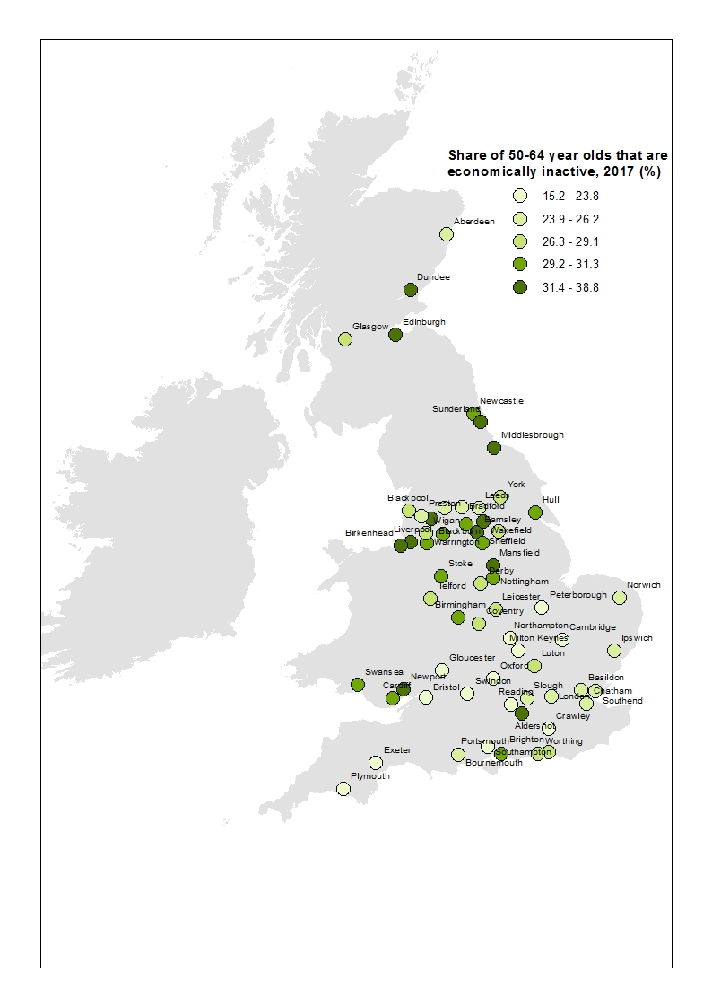

* These differences seem to be related to the economic performance of places: those with a strong economy (i.e. higher GVA per worker) tend to have a lower share of 50-64yo that are economically inactive.
* This could also be related to the decline in manufacturing and mining over the last 50 years and the impact the policy response the government adopted.

**Breakdown by qualification (Census)**

* Despite accounting for 30 per cent of the working age population of England and Wales, people with few or no qualifications account for 46 per cent of the working age population that is economically inactive.
* In contrast, people with higher-skilled qualifications account for 30 per cent of the working age population but only for 16 per cent of the economically inactive population of England and Wales.
* But there is variation across the country: in Mansfield and Barnsley, low-skilled people account for two-thirds of the economically inactive, in Wakefield for 60 per cent of the economic inactive.
* On the other hand, only 16 per cent of the economically inactive in Cambridge are low-skilled and 20 per cent in Oxford.
* Low-skilled people are much more likely to be economically inactive than those with higher-level qualifications.
* 36 per cent of all low-skilled in England and Wales are economically inactive, but the share is even higher in places with weaker economies: in Blackburn, 45 per cent of low-skilled people are economically inactive, in Liverpool 44 per cent and in Swansea 43 per cent.

**Breakdown by living arrangement (Census)**

* On average, 36 per cent of those 16 years old or over were economically inactive in 2011 in England and Wales. However, the percentage is lower for those living in a couple: only 32 per cent were economically inactive, and higher for those living on their own, 41 per cent of those not living in a couple were economically inactive in 2011.
* Of all the economic inactive in England and Wales, 48 per cent were not in a couple.

1. **Why are people economically inactive?**

**Breakdown by reason**

* 27 per cent of the economic inactive in Greater Britain are students, 25 per cent are looking after family/home and 22 per cent are long-term sick.
* There is a strong positive relationship between economic inactivity of ethnic minorities and people that are economically inactive and look after family/home (i.e. basically work but not in the labour market).
* This suggests that in places like Slough, Luton and Bradford where the share of economic inactivity is high and strongly related to the demographic of the city, the numbers may hide part of the story: that is, these people are not active in the labour market but nevertheless work.
* In contrast, there is a strong negative relationship between the share of economically inactive that are long-term sick and productivity. The cities with the lowest productivity, such as Mansfield, Barnsley and Blackburn have a much higher share of economically inactive that is long-term sick.

**Breakdown by whether they want a job or not**

* When splitting the economic inactive between those who do want a job and those who do not want a job, it emerges that the vast majority of economically inactive in Great Britain does not want a job (77%).
* There is variation between cities, with Chatham being the city with the higher share of economically inactive that do want a job (41%) and Birkenhead the city with the lowest share (11%), but these differences seems not to relate to any measures of economic performance of other characteristics of cities in particular.

|  |  |
| --- | --- |
| **Variable** | **Correlation to share of economically inactive that do want a job** |
| Welfare spend per capita | 0.15 |
| Population aged 45-64yo | 0.14 |
| GVA per worker | -0.04 |
| High-skilled population | -0.10 |
| No-skilled population | -0.19 |
| Share of KIBS | -0.30 |

* Of all the indicators, the one that seems to better correlate with the share of economically inactive wanting a job is the share of knowledge intensive business services, but the correlation is weak.

1. **Why do we see variations in economic inactivity across the country?**

* When looking at the reasons why there are differences in economic inactivity in cities up and down the country, a number of indicators appear to be strongly correlated with economic inactivity.
* In particular, the share of population with no qualification seems to be strongly positively correlated with the share of economic inactive (correlation coefficient of 0.63).
* There is also a negative correlation between productivity and economic inactivity (correlation coefficient of -0.40): the more productive a city is, the lower the economic inactivity rate.
* There are weaker negative correlations between the share of KIBS in a city and economic inactivity (correlation coefficient of -0.28), average weekly earnings and economic inactivity (correlation coefficient of -0.28) and the share of high-skilled population in a city and economic inactivity (correlation coefficient of -0.18)
* Not surprisingly, there is a positive correlation between welfare spend per capita and economic inactivity (correlation coefficient of 0.47).
* There is also a positive correlation between unemployment rates and economic inactivity (correlation coefficient 0.40) with places with higher unemployment rates also having higher economic inactivity.